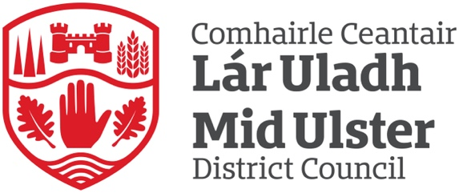

Mid Ulster District Council
Complaints Handling Data
1st April 2024 – 30th September 2024

Complaints Handling Reports
In accordance with guidance issued by the Northern Ireland Public Services Ombudsman (NIPSO), the Council adopted new Complaints Handling Procedures (CHP) on 1 January 2024.
These procedures provide a governance framework for the capture of complaints across Mid Ulster District Council. The Council is required to publish complaints data on a 6-monthly and annual basis.
All complaints are progressed in accordance with the new procedures, ensuring that the handling of complaints will be in line with statutory requirements established by the Public Services Ombudsman Act (NI) 2016.

1 April 2024 to 30 September 2024
Mid Ulster District Council is committed to providing a high standard of customer service to all its citizens.
‘We value complaints and use them to help improve our services’
For the 6-month period 1 April 2024 to 30 September 2024 Mid Ulster District Council received 32 Stage 1 complaints, and 8 Stage 2 complaints (7 heard at Stage 1, and 1 escalated straight to Stage 2).
Most complaints fell under the category of ‘inadequate quality or standard of service’ (59%), with the remaining complaints categorised as detailed below:

Complaint Categories:
Inadequate quality or standard of service | 59%
Unreasonable delay in providing a service | 3%
Failure to properly apply law, procedure or guidance when delivering services | 13%
Failure to follow the appropriate administrative process | 3%
Conduct, treatment by or attitude of a member of staff or contractor | 19%
Disagreement with a decision (except where there is a statutory procedure for challenging that decision, or an established appeals process) | 3%

Complaints received for the period 1 April 2024 – 30 September 2024 were investigated in line with statutory guidelines and closed on the basis of the following outcomes:
Complaint Outcomes
Resolved | 60%
Upheld | 6%
Partially Upheld | 3%
Not Upheld | 31%

Complaints are received through a number of ways. The following data from 1 April 2024 – 30 September 2024 provides a breakdown of the channels used by citizens to engage with the Council when logging a complaint.
Channels
Email | 41%
Telephone | 9%
Letter | 3
Online | 47%

Lessons Learned
The Council will systematically review and analyse complaints to ensure that lessons have been learned, services improved, and appropriate action taken.
Detailed below are examples of service improvements as a result of the administration of the complaints handling procedures:
- General cleaning procedures reviewed within Leisure Centres
- Cleaning schedule for playparks reviewed and monitored - identified need to increase washing maintenance at parks that are surrounded by foliage
- Review of supervisory rota cover in Leisure Centre gyms
- Staff reminded of the importance of confidentiality in data handling
- Refresher training on Customer Service & Equality training

For further information on our Complaints Handling Procedures please visit https://www.midulstercouncil.org/complaints

