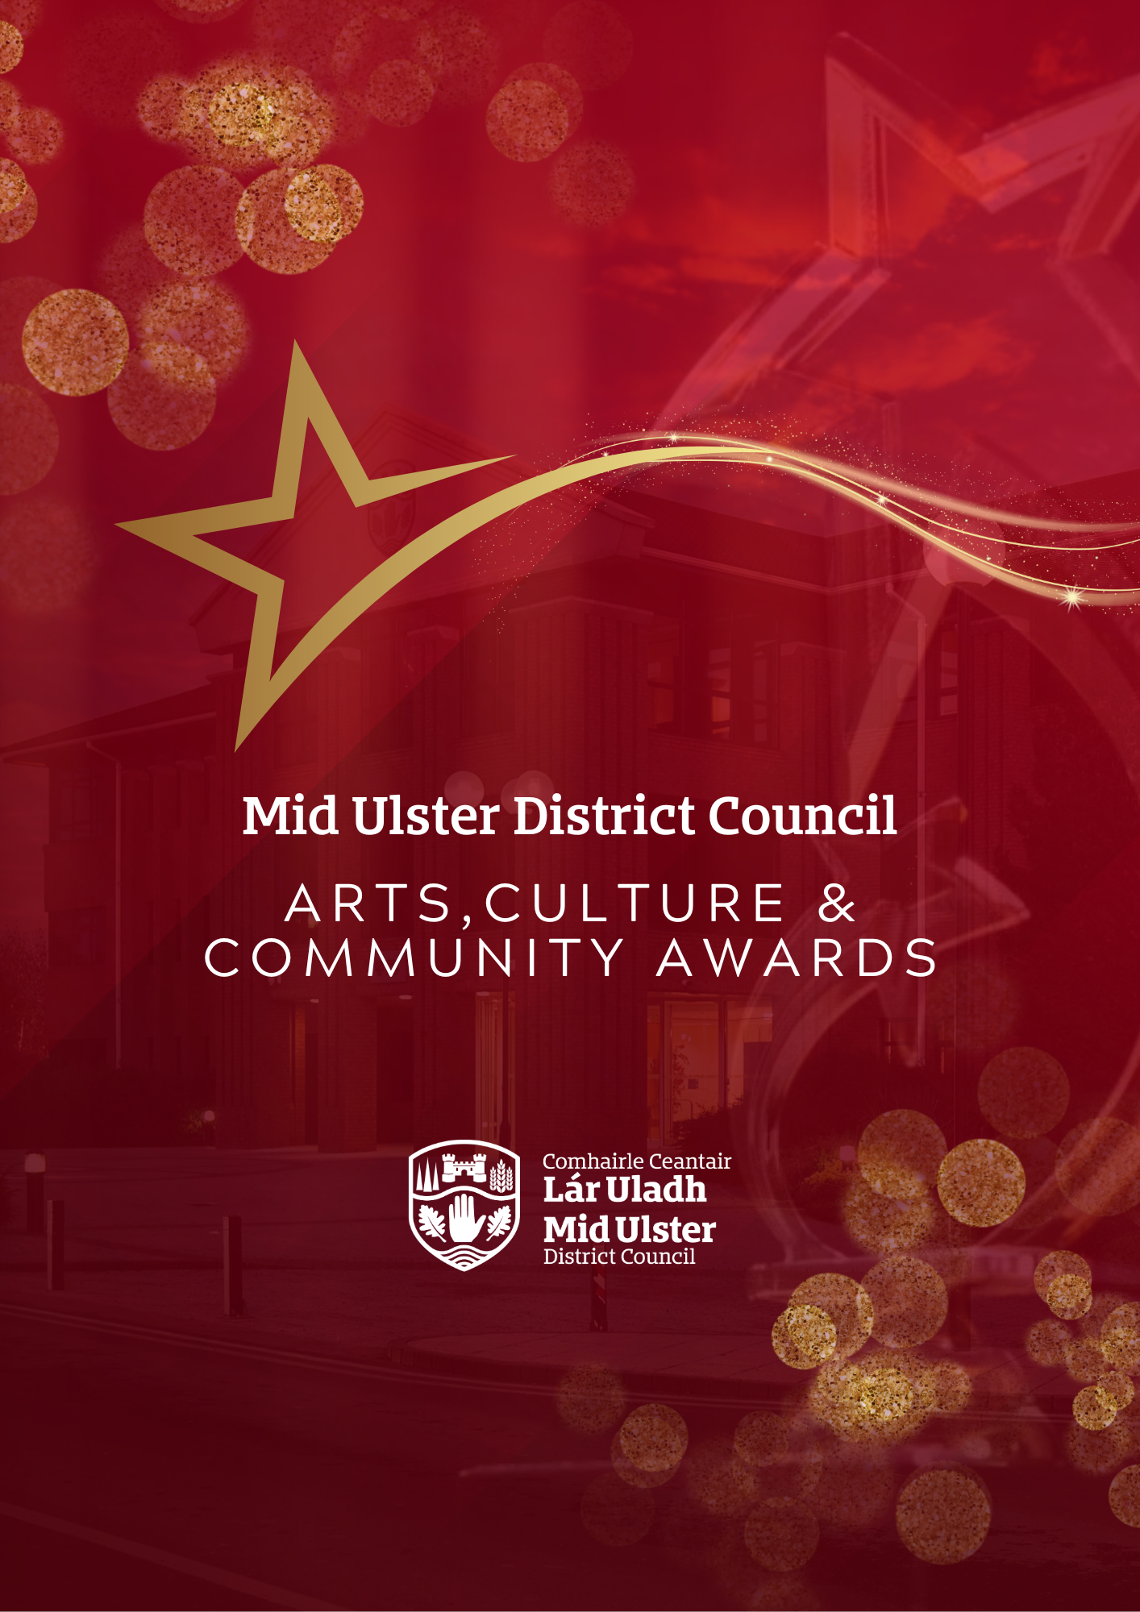

Guidance for Arts, Culture & Community Awards 2025

**A red background with a star and text
**

|  |  |  |
| --- | --- | --- |
| **GUIDANCE FOR NOMINATORS**  Mid Ulster District Council Arts, Culture & Community Awards 2025 aim to recognise groups and individuals who make a valuable contribution to community life.  These awards are designed to give you the opportunity to recognise and thank local people and groups of outstanding merit for making a difference to the lives of others in our Council area.  These outstanding groups and individuals can be from any walk of life, and any part of the Council area.  We want to hear about them now, it’s free and easy to nominate. Simply fill in and submit an entry form right away.  **The winners will be announced at our Mid Ulster District Council Arts, Culture & Community Awards on Tuesday 25 March 2025 in the Burnavon Arts Centre Cookstown.** |  | **NOMINATIONS**  **Nominations must be received by 21 2025 in order to be considered for the Arts, Culture & Community Awards 2025**.  All nominations received after that date will not be considered.  The Judges decision is final and no correspondence will be entered into.  Please read the criteria carefully before making an application. If you feel that the organisation or individual meets with the criteria then select the category and that best applies to the organisation or individual you have in mind.  Please note the Judging panel may (at their discretion) change the category to the most appropriate one e.g. that best fits the nomination.  Judging will be a 2 stage process with Stage 1 Eligibility Assessment and Stage 2 Assessment Scoring.  Please ensure to complete you application as accurately as possible within the word limit provided.  **The decision of the judging panel is final.** |

**A red background with a star and text

**

**NOMINATIONS**

1. In the case of the “individual” category, self nominations will not be accepted, nor will nominations from immediate family members.
2. Nominators may submit a maximum of three nominations for a group/individual but cannot nominate more than one group/individual into any one category. Separate nominations forms must be submitted for each group/individual.
3. Nominees voluntary or professional work must be of benefit to the people and life of the District
4. All nominees must have undertaken the work for which they are being nominated in a voluntary or professional capacity.
5. All nominees are required to have a minimum of two years involvement in the activity for which they are being nominated. However, this is not a requirement for the Categories under ‘Youth Award’. A minimum of one year’s voluntary service is required for these awards.
6. Number of nominations received for a group and/or individual is not considered in the assessment process. This is an application process as per the criteria being assessed.



**AWARD CATEGORIES**

|  |  |
| --- | --- |
| **CATEGORY** | **DESCRIPTION** |
| **Arts Person of the Year** | This award recognises an individual who has undertaken imaginative work in any one of the arts, such as drama, dance, music, literature, the visual arts and crafts including photography, and/or demonstrated good practice in the organisation of arts, projects and events. |
| **Young Arts Person of the Year** | This award recognises a young individual (under 18) who has undertaken imaginative work in any one of the arts, such as drama, dance, music, literature, the visual arts and crafts including photography, and/or demonstrated good practice in the organisation of arts, projects and events. |
| **Arts Group of the Year** | This award celebrates a group who have demonstrated exceptional achievements in any one of the arts, such as drama, dance, music, literature, the visual arts and crafts including photography, and/or demonstrated good practice in the organisation of arts projects and events. |
| **Youth Champion Award** | This award recognises the group which best demonstrates how they are assisting in meeting the needs of young people e.g. running a youth club, lobbying for youth facilities, or helping young people reach their full potential. |
| **Age Friendly Award** | This award recognises a group which can best demonstrate how they are assisting in meeting the needs of older people e.g. running an older person’s club, lobbying for facilities, or helping older people resolve local issues. |
| **Equality & Good Relations Award** | This award recognises a community led group which displays and encourages Diversity and Integration and promotes equality of opportunity. This group will have led on diversity and integration initiatives and on supporting and engaging our minority or section 75 communities in Mid Ulster. |
| **Community Eco Award** | This award recognises a community led group who undertake Eco or environmental initiatives/activities in their local areas that engage a wide number of people, both young and old. |
| **Health & Well-being Award** | This award recognises the group which works to promote health and well-being within the Council area e.g. activities organised promoting good mental health, staying active, tackling poverty and social exclusion, healthy eating etc. |
| **Community Safety Award** | This award recognises the group or individual who can demonstrate how they are making their community a safer place. |
| **Community Champion** | This award recognises an individual who has demonstrated outstanding service to the community, made a significant contribution to public life in Mid Ulster and have shown real dedication in helping local residents. |
| **Volunteer of Year Award** | This award recognises an individual who has displayed dedication to others and /or is making a difference to people’s lives. |
| **Lifetime Achievement Award** | This award is for an individual who has displayed high levels of voluntary achievement over a significant period of time (minimum 20 years). |

**A red background with a star and text

**

|  |  |  |
| --- | --- | --- |
| **RETURN OF NOMINATIONS**  **Nominations can be made online at: midulstercouncil.org/awards**  If you are unable to submit an online nomination, you should contact one of the officers listed below.  Hard copy applications WILL NOT be accepted unless you have obtained prior permission from one of the officers below.  For more details on the Arts, Culture & Community awards you can contact:  Catherine Fox  Email: catherine.fox@midulstercouncil.org  Phone: 03000 132 132  **Entries must be received by 12 noon on 21February 2025, applications after this date WILL NOT be accepted.** |  | **ASSESSMENT PROCESS**  Assessment will be carried out by Officers using a standard assessment process. Criteria for submitting an application to any category are as follows:  **STAGE 1 – ELIGIBILITY CHECK**  All nominations will be checked against criteria at Appendix 1 – this is a Pass or Fail on 5 areas. All 5 areas must be a pass in order to proceed to Stage 2 (assessment).  Nominee has not received a Council Award previously for the category which they are being entered into.  **STAGE 2 – ASSESSMENT**  Applications deemed eligible from Stage 1 will proceed to Stage 2 and will be scored against criteria specific to the Award Category they have been nominated to.  Answers will be scored based on the scoring matrix provided in Appendix 2. |

**A red background with a star and text

**

**APPENDIX 1**

**STAGE 1 – ELIGIBILITY CHECK**

|  |
| --- |
| **Name of Group/Individual:** |
| **Category:** |

|  |  |
| --- | --- |
| **CRITERIA** | ***Eligible? (Tick or X***  ***or N/A)*** |
| In the case of the “individual” category, self-nominations will not be accepted, nor will nominations from immediate family members. |  |
| Nominees’ voluntary or professional work must be of benefit to the people and life of the district. |  |
| All nominees must have undertaken the work for which they are being nominated in a voluntary or professional capacity. |  |
| All nominees are required to have a minimum of two years involvement in the activity for which they are being nominated. However, this is not a requirement for the categories ‘Under 18 Youth Volunteer ward’. A minimum of one year’s voluntary service is required for the ‘Under 18 Youth Volunteer Award’ category. |  |
| This is not open to sporting organisations/individuals as the Council organises a separate Sports Awards Evening. |  |

**Eligible to proceed to stage 2? Yes/No (delete as appropriate)**

**A red background with a star and text

**

**APPENDIX 2**

**STAGE 2 – BASIC SCORING CRITERIA FOR RESPONSES**

|  |  |
| --- | --- |
| **ASSESSMENT** | **SCORE** |
| An **excellent** response which exceeds the requirements in a very comprehensive manner | 5 |
| A **good** response which meets the requirements in a comprehensive manner | 4 |
| A **satisfactory** response but concerns expressed by the judging panel on some aspects | 3 |
| **Minimal / poor** information or inappropriately provided | 2 |
| The applicant **failed** to address the question | 1 |

**Mid Ulster District Council logo, a red and black shield with leaves and wheat

**